Practical - 1
Practical Title: Project Initiation, Requirement Analysis, Sitemap, Wireframe, and GitHub Setup

Problem Definition: Initiate the semester-long Student Hub portal by identifying the problem scope, user roles, key modules, navigation flow, and minimum 10 pages. Create a sitemap, low-fidelity wireframe, project folder structure, README file, and GitHub repository.

Theory

What is URL and parts of URL?
Answer:
A URL (Uniform Resource Locator) is the address of a web page on the internet. It helps the browser find and open a website.
References:
https://developer.mozilla.org/en-US/docs/Learn_web_development/Howto/Web_mechanics/What_is_a_URL

- How does HTML file process in web browser?
Answer:
When we enter a URL, the browser requests the HTML file from the server. The browser reads the HTML code, loads CSS and JavaScript, and then displays the webpage on the screen.
References:
https://developer.mozilla.org/en-US/docs/Learn_web_development/Getting_started/Web_standards/How_the_web_works?

How will page navigation flow managed among all HTML pages?
Answer:
Every page has navigation links that connect to other HTML pages.
References:
https://developer.mozilla.org/en-US/docs/Learn_web_development/Core/Structuring_content/Creating_links?

4. How will GitHub commits be maintained after each practical?
Answer:
After completing each practical, the updated files will be saved, committed, and pushed to GitHub with a clear commit message.
References:

https://docs.github.com/en/get-started/learning-about-github/github-glossary?

Implementation/ Output/Result
Key Modules
Home - Login - Dashboard - Attendance - Assignments - Study Materials - Timetable - Results - Profile - Contact Us

Evidence of Work (Screenshots)
Description: figure 1.1 sitemap of student portal It represents the structure of the website and the connection between different pages. The sitemap helps to understand the navigation flow and organization of the student portal.
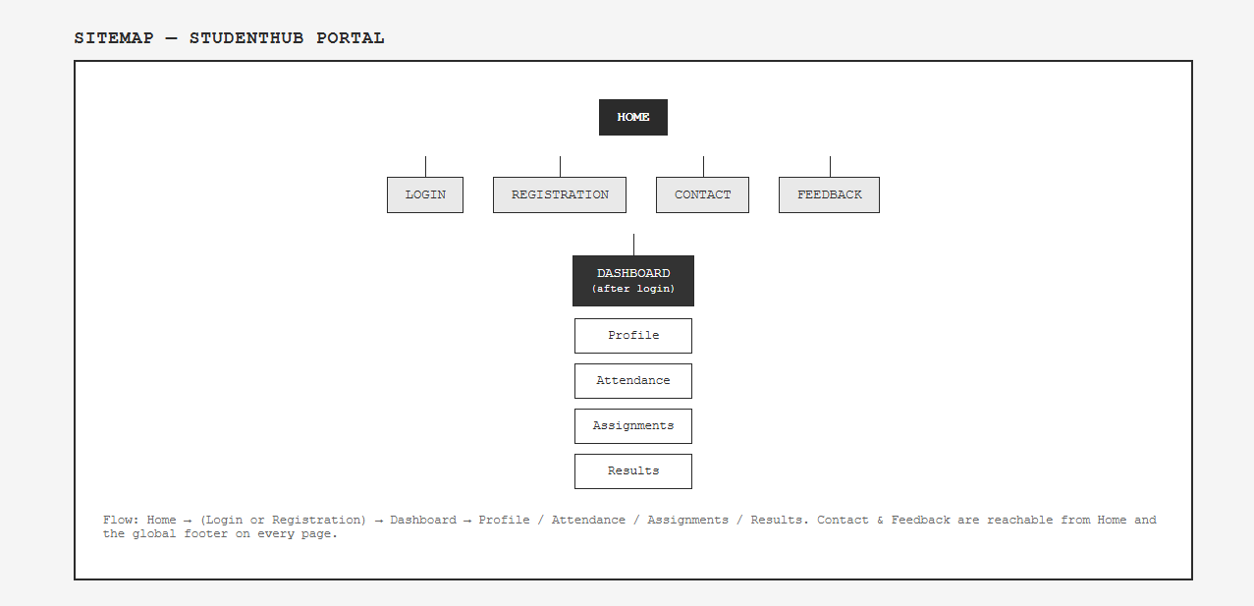

Description: Figure 1.2 shows the Home Page of the Student Hub Portal. It provides the main introduction to the portal and gives users access to different sections.
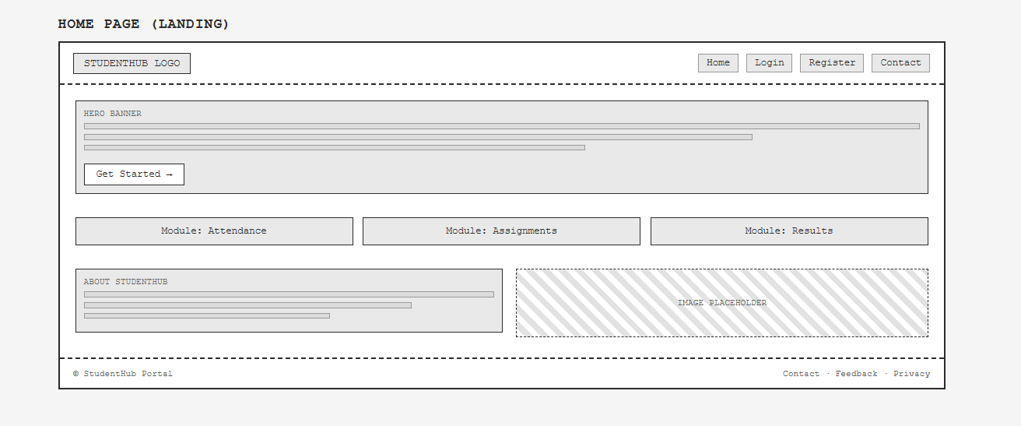

Description: Figure 1.3 shows the Registration Page of the Student Hub Portal, where students enter details such as name, email, mobile number, and password to create an account.
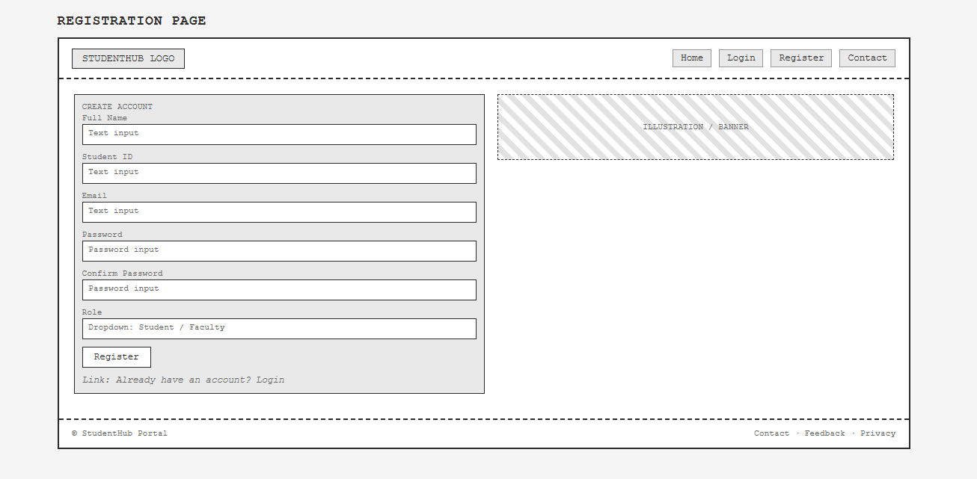

Description: Figure 1.4 shows the Login Page of the Student Hub Portal, where students enter their email and password to access their account.
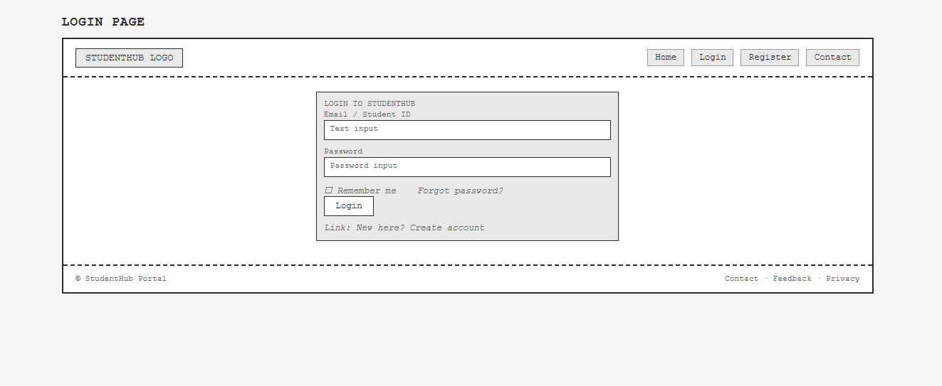

Description: Figure 1.5 shows the Profile Page of the Student Hub Portal, where students can view their name, email, mobile number, course, and other personal details.
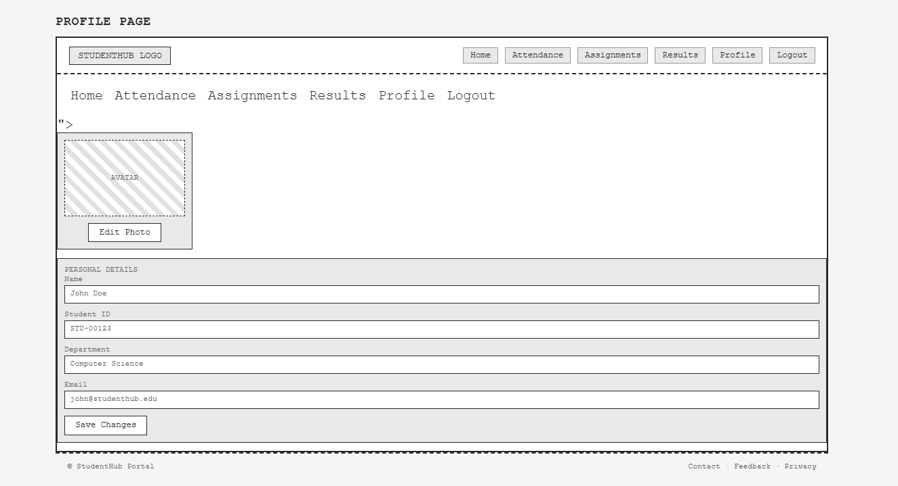

Description: Figure 1.6 shows the Dashboard Page of the Student Hub Portal, where students can view attendance, assignments, results, study materials, and other important academic information.
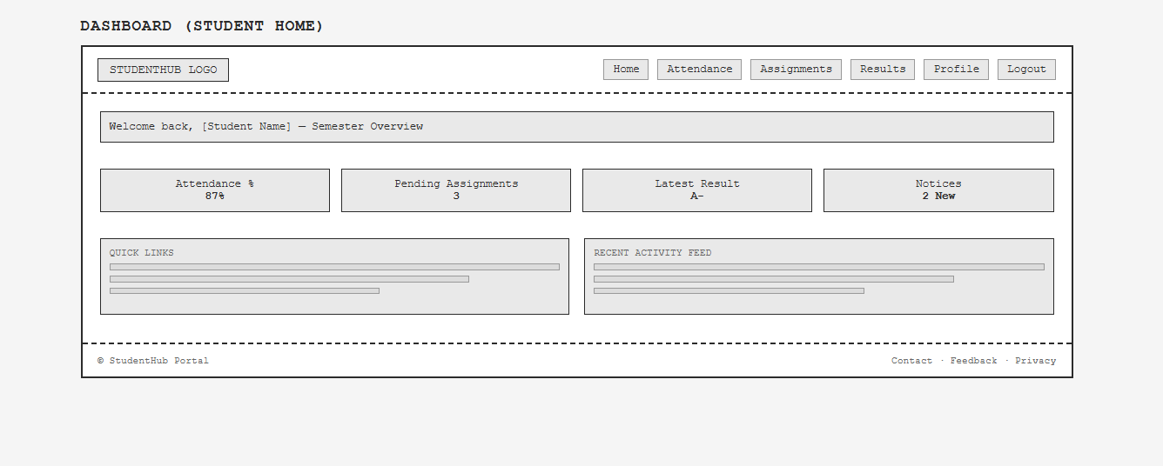

Description: Figure 1.7 shows the Attendance Page of the Student Hub Portal, where students can view their subject-wise attendance and attendance percentage.
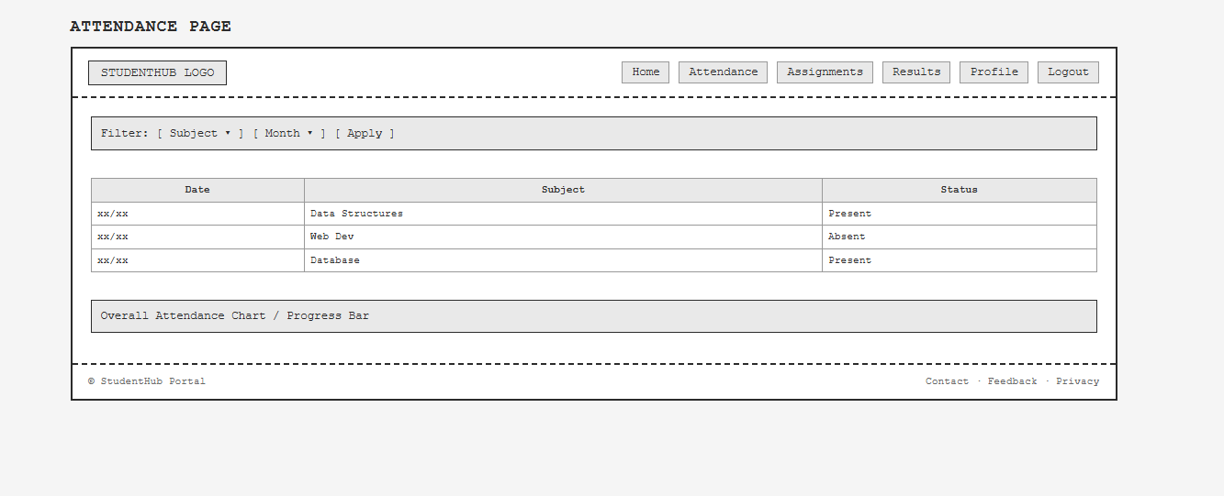

Description: Figure 1.8 shows the Assignments Page of the Student Hub Portal, where students can view subject-wise assignments, deadlines, and submission details.
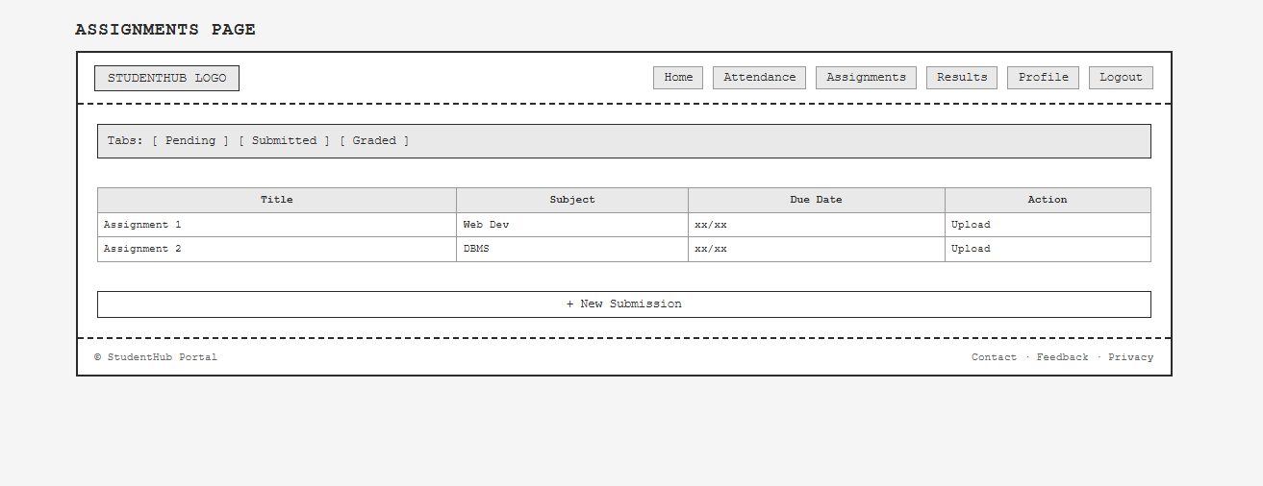

Description: Figure 1.9 shows the Results Page of the Student Hub Portal, where students can view subject-wise marks, grades, SGPA, CGPA, and overall results.
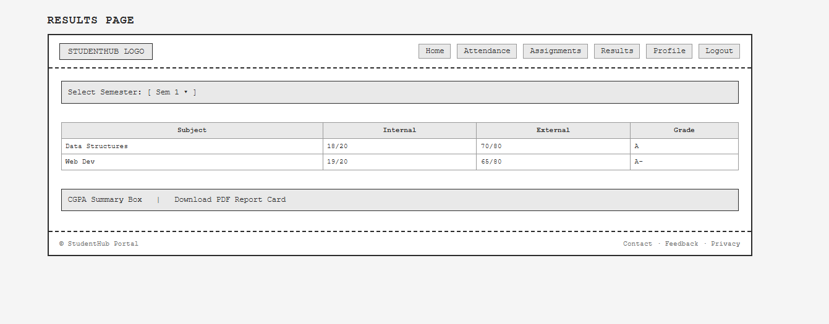

Description: Figure 1.10 shows the Contact Page of the Student Hub Portal, where students can view contact details and send their queries or messages.
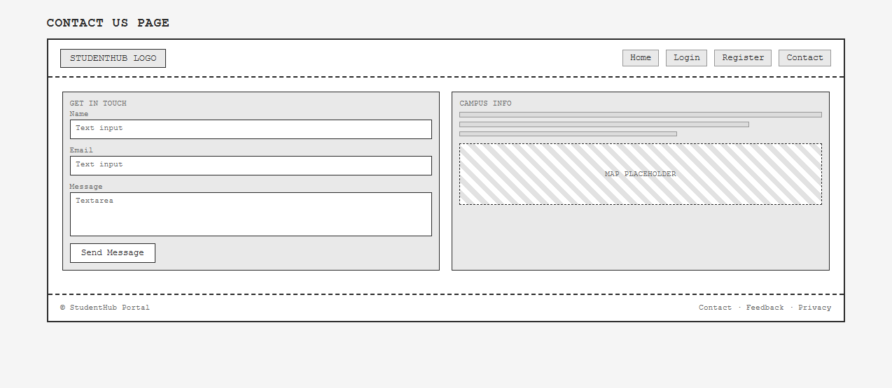

Description: Figure 1.11 shows the Feedback Page of the Student Hub Portal, where students can give ratings and share their feedback about the portal.
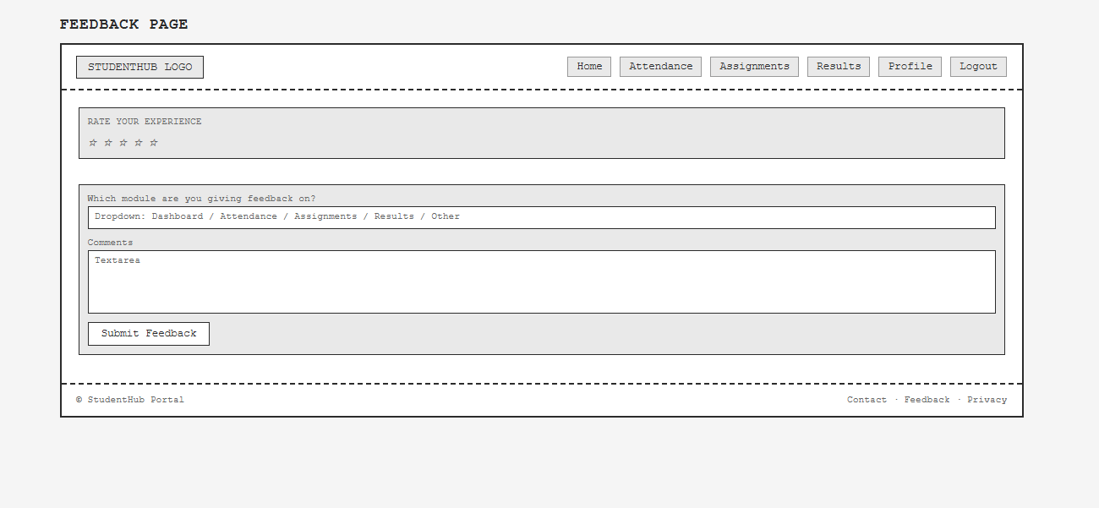

GitHub Repository Link:
Link: https://github.com/meetp2m/Student-Portal-wireframes-Practical-1

Challenges Faced:
I have problem in how to add my wireframe pdf in my git hub account so I am fixed this problem by asking to google and ai.

Learning Outcomes:
I am learning many things like how to make a wireframe for my practical 1 and how to use a git hub account for my repositories.

Faculty Remarks:

